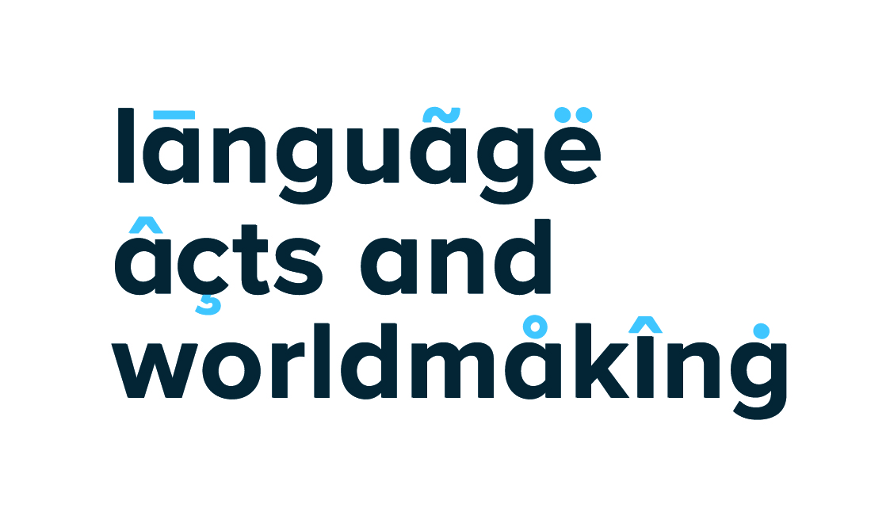

Small Grants Funding Form

Language Acts and Worldmaking welcome applications for funding for small projects and events as part of our small grants scheme. Applications can be made to fund workshops, conferences, public events, or other projects that resonate with the theme of Integration and Inclusion, and the aims and objectives of the Language Acts and Worldmaking project. For details, please see our ‘Call for Small Grants proposals’ document attached with this form.
The deadline for this round of funding is midnight on 31 January 2019.
To apply for funding, please complete this form in full and email to languageacts@kcl.ac.uk ahead of the funding deadline.

1. Personal details
Name
Email address
Applicant details | ☐ | Student. Please give details of current course of study and institution:
 | ☐ | Modern Languages professional. Please give title and institution:
 | ☐ | Individual/Related professional. Please give title or affiliation:

2. Type of application
Workshop arrangement | Conference arrangement | Public event arrangement | Other
Maximum funding available
£500 | £1,500 | £1,500 | £1,000

3. Event details:
Title and brief description of workshop/conference/public event proposed:

Proposed location:

Proposed attendees (individuals and/or groups):

If awarded funding to arrange a workshop/conference/public event, please confirm that you would be willing to submit a short report or blog-post for the Language Acts and Worldmaking website. | Yes

4. Budget
Please give details of proposed costs. Amend cost categories and add additional rows as needed, and state all costs in GBP only.
If you are in receipt of other funding to support these activities, please give details and deduct this from funds requested.
Costs | Details | Total
Catering (standard catering costs only):
Guest Speaker Travel and/or Accommodation:
Event Materials:
Printing:
Other: (Please specify)

Other: (Please sp ecify)

Other: (Please specify)

Total budget
Details of any additional funding received to support this activity
Total funding in place
Total funding requested in this application

5. Description of project
Describe the background to the project for which you are seeking support including the ways in which the project builds on existing work, or marks a new departure from current research interests and methodologies. Describe the overarching research questions that the project will address.

6. Timeline and project plan
Please identify the timing of the activities that you will undertake during the award period.

7. Justification of resources
Why have you requested the resources outlined in the budget?

8. Potential benefit
Please describe how the proposed activity relates to, and/or expands upon, the aims and objectives of Language Acts and Worldmaking, and how you think this would be beneficial to your own research, other participants, and the project.

9. Future plans
Describe how you will develop your research, teaching, outreach, collaborative activity after the award. How will the award contribute to your future plans?

Signed: Date:

References
Please give contact details of two referees to support your application:
Name:  Title/role:  Organisation (if applicable):  Email address:  Telephone number: | Name:  Title/role:  Organisation (if applicable):  Email address:  Telephone number:

